Keswick hunt club SPORTING CLAYS TOURNAMENT
April 6, 2024
EAST END * LOUISA, Virginia

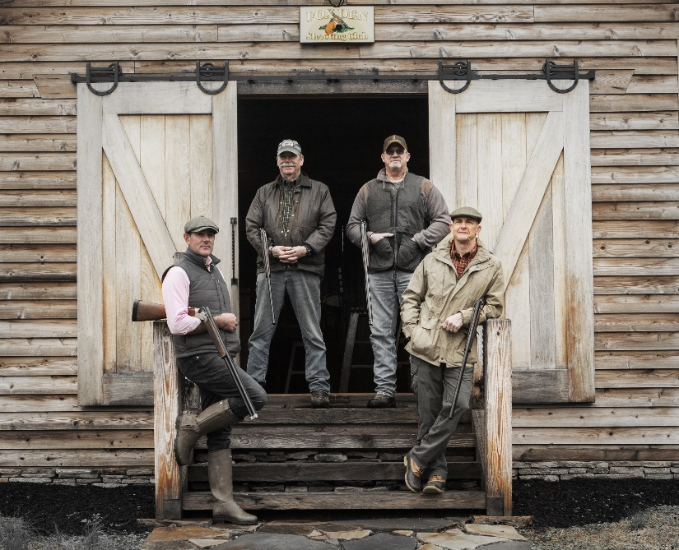

STATION SPONSORSHIP: $200 Sponsorship is awarded upon KHC receiving this form.
Become a station Sponsor for the 2024 KHC Annual Clay Tournament and receive great exposure while supporting a great cause! Help KHC make our Spring Clay Shoot a success!
Station Sponsorship Includes:
A sign with your name/company name to be displayed at your sponsored station, and
Recognition in the KHC social media.
Only 30 station sponsorships available—first come, first served!

Name: _______________________________________ Contact Person: _____________________________
Email: ________________________________________ Phone #: ___________________________________
Signature: _____________________________________
Name/Company Name as displayed on the sign:
_____________________________________________________________________________________________
Please mail form and $200 check payable to Keswick Hunt Club, Inc. to:
P.O. Box 227; Keswick, VA 22947
Questions? Call or text Kat Wisner (954) 495-1757 or email @ keswickhuntclub1896@outook.com

